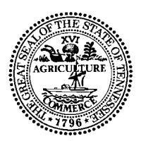

Form #RV-F1301301
STATE OF TENNESSEE

DEPARTMENT OF REVENUE

NASHVILLE

GOVERNMENT CERTIFICATE OF EXEMPTION

Date: March 18, 2013

TO: Jostens

The undersigned hereby certifies that the purchase of tangible personal property or services being made on this certificate of exemption are being made by the State of Tennessee, or a county of municipality within the State of Tennessee or the Federal Government, or an agency thereof, and are for the use of such government or agency.

The undersigned further certifies that the said government or agency is making the purchase directly from the above named vendor, and will obtain title or has title to the property immediately when it is delivered, and will use public funds to pay directly to the above named vendor for the tangible personal property or services obtained upon this certificate of exemption.

Our Federal ID # is 62-0714744.

Name of Government Agency:

CLARKSVILLE-MONTGOMERY COUNTY SCHOOL SYSTEM

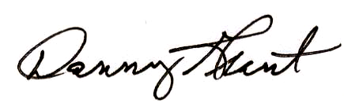

Chief Financial Officer

Cumberland Heights Elementary School
2093 Ussery Road South Clarksville, TN 37040
(931) 648-5695 Fax (931) 503-3400

